# ­ US_001: Pixyle Login Page User Story:

|  |  |
| --- | --- |
| Description | As a customer, I want to login with my credentials so I can securely access my online account |
| Assigned To | PO (Product Owner) |
| State | Ready / In Design / Done / In Review |
| Priority | High |
| Risk | High |

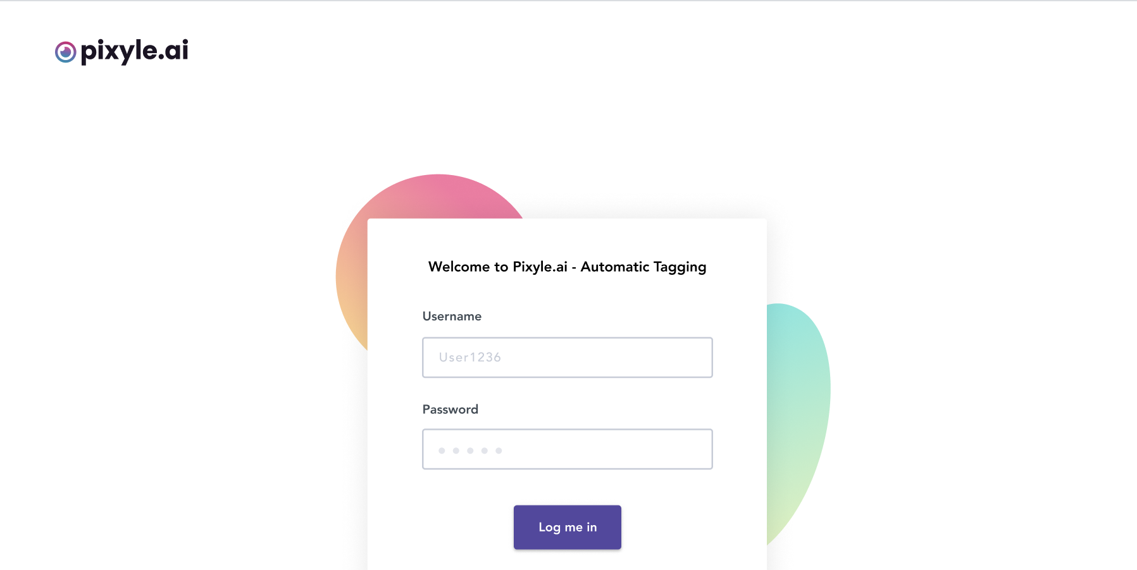

Acceptance Criteria:

|  |  |
| --- | --- |
| Username | Input type field with 256 max chars |
| Password | At least 7 chars, 1 number, 1 uppercase letter, 1 lowercase letter, 1 special char |
| Log Me In | Type Button |

All fields are required data fields - error alert should be shown if user clicks on “Log Me In” button without typing anything in the required fields.

Password criteria should be displayed to the user when user clicks inside the password data field.

Green check mark next to 'Password' data field should be displayed that indicates to the user after typing password that the entry meets criteria

Red mark next to 'Password' data field should be displayed that indicates to the user after typing password that the entry does not meet criteria

After successful validation of all entered fields and on clicking “Log Me In” button, a confirmation message for successful login appears.

# ­ US_002: Pixyle Reset Login Credentials:

|  |  |
| --- | --- |
| Description | As a customer, I want to login with my credentials so I can securely edit/modify my online account |
| Assigned To | PO (Product Owner) |
| State | Ready / In Design / Done / In Review |
| Priority | High |
| Risk | High |



Acceptance Criteria:

|  |  |
| --- | --- |
| Username | Input type field with 256 max chars |
| Password | At least 7 chars, 1 number, 1 uppercase letter, 1 lowercase letter, 1 special char |
| Log Me In | Type Button |

All fields are required data fields - error alert should be shown if user clicks on “Log Me In” button without typing anything in the required fields.

Password criteria should be displayed to the user when user clicks inside the password data field.

Green check mark next to 'Password' data field should be displayed that indicates to the user after typing password that the entry meets criteria

Red mark next to 'Password' data field should be displayed that indicates to the user after typing password that the entry does not meet criteria

After successful validation of all entered fields and on clicking “Log Me In” button, a confirmation message for successful login appears.

# US_003_Account_Settings:

|  |  |
| --- | --- |
| Description | As a customer, I want to login with my credentials so I can securely edit/modify my online account |
| Assigned To | PO (Product Owner) |
| State | Ready / In Design / Done / In Review |
| Priority | High |
| Risk | High |

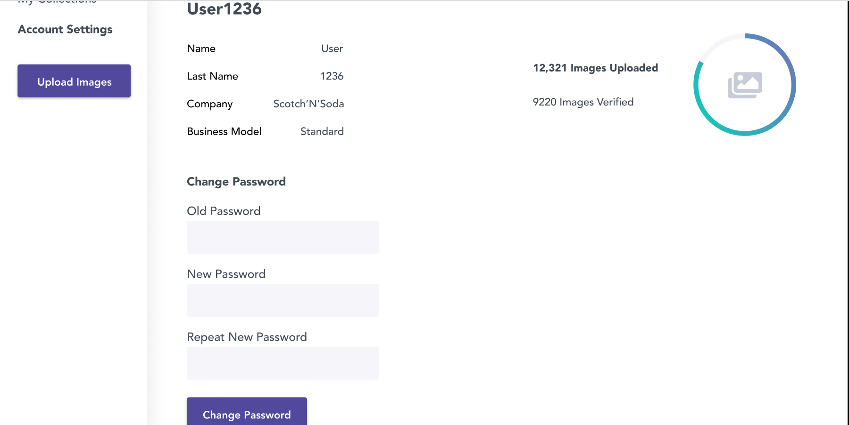

Acceptance Criteria:

|  |  |
| --- | --- |
| Old Password | At least 7 chars, 1 number, 1 uppercase letter, 1 lowercase letter, 1 special char |
| New Password | At least 7 chars, 1 number, 1 uppercase letter, 1 lowercase letter, 1 special char |
| Repeat New Password | At least 7 chars, 1 number, 1 uppercase letter, 1 lowercase letter, 1 special char |
| Change Password | Type Button |
| Name | Label (text) – non editable |
| Last Name | Label (text) – non editable |
| Company | Label (text) – non editable |
| Business Model | Label (text) – non editable |

'Old Password', ‘New Password' and ‘Repeat New Password'’ entries should be masked  
Password entries will show the keystroke typed, and then after certain time (1s) the entered character is masked.

If 'Old Password' entry does not match criteria specified and user hits Change Password, error alert "Password entry does not meet criteria" will be shown.

If entries in 'New Password' and Repeat New Password' do not match and user hits Change Password, error alert 'Password entries do not match' is shown.

After successful validation of all entered fields and on clicking Change Password button, message is shown indicating successful account modification.